

| **TITLE**: Design and animate the following: Pendulum /Collision of object /Water waves |
| --- |

**AIM:**

Use the Blender software or any other open source software to create and animate

All Batch needs to Design Donut object

D1: Pendulum

D2: Collision of object

D3: Water waves

**______________________________________________________________________**

**Expected OUTCOME of Experiment:**

Learn designing n animation using blender.

**_____________________________________________________________________**

**Books/ Journals/ Websites referred:**

Blender

Google

**_____________________________________________________________________**

**Steps to perform:**

**DONUT:**

### Create Donut Shape

* Add Torus: Shift + A > Mesh > Torus.
* Adjust size and segments in the properties panel.

### Model Icing

* Duplicate top half in Edit Mode (Tab > select vertices > Shift + D).
* Scale slightly larger and move up.

### Add Sprinkles

* Add Plane: Shift + A > Mesh > Plane.
* Scale down, shape, and apply random colors.
* Duplicate and scatter over icing.

### Texturing

* UV Unwrap the donut and icing.
* Apply textures: Use a dough texture for the donut and a glossy material for the icing.

### Lighting and Rendering

* Add lighting: Shift + A > Light > Area Light.
* Set up camera: Shift + A > Camera, position and adjust.
* Render: Press F12 to render the image.

**PENDULUM:**

### Model the Chain Links

* Create a Single Chain Link:
  + Add Torus: Shift + A > Mesh > Torus.
  + Scale and adjust the thickness to resemble a chain link.
* Duplicate and Rotate Links:
  + In Edit Mode, duplicate (Shift + D) and rotate (R) the link to form a chain.
  + Repeat to create the desired length of the chain.

### Model the Pendulum Bob

* Add Bob:
  + Add Sphere: Shift + A > Mesh > UV Sphere.
  + Scale it to the desired size for the bob.
  + Position it at the end of the chain.

### Set Up Physics Simulation

* Enable Rigid Body Physics:
  + Select the chain links and the bob, then go to the Physics tab.
  + Enable "Rigid Body" and set the "Type" to "Active" for the bob and "Passive" for the first link.
* Link Chain Links:
  + Select each link, then go to the Physics tab, and set "Collision Shape" to "Mesh".
  + For each link, set "Rigid Body Constraint" to "Point" or "Hinge" to connect them.

### Animate the Pendulum

* Set Initial Position:
  + In Object Mode, position the bob and chain at the starting angle.
* Simulate Motion:
  + Play the animation to see the physics simulation in action.

**Drive or GitHub/ google drive link:**

Donut: <https://drive.google.com/file/d/1R5xG_ry1SfzncPonwepxsjA_VNYc1RZ_/view?usp=drive_link>

Pendulum: <https://drive.google.com/file/d/18MEx_9-bxbn0vXbLYrDS1uhF2F665LY4/view?usp=drive_link>

**Output(s) (Screen Shots):**

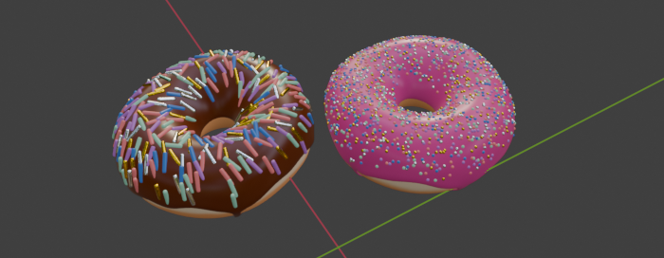

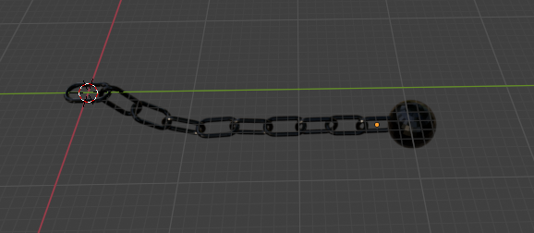

**Conclusion and discussion:**

Learnt how to use blender tools and enhance technical skills in 3D modeling.